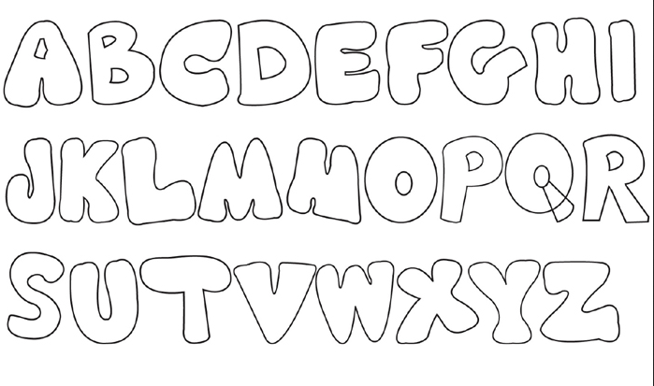

GREY GREEN RED WHITE YELLOW BLUE DARK

